**смотри сайт прототип (http://vshevchuk.ru/)**

-------------------------------------------------------- HEADER -----------------------------------------------------------

**Menu :**

**Mikhail Biazverkhi Home | About | Skills | Projects | Achievements | Contact me**

* **ANG / FR**

**HERO (фоновое фото - веб-разработка)**

**------------------------------------------------------------------------------------------------------------------------------**

Section : **About (обо мне)**

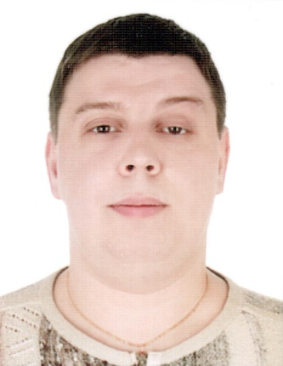" I have accumulated 6 years of experience in the IT field, having held positions as a system administrator, automation tester and backend developer. When I arrived in Canada, I chose to become a web developer to express my creativity. My varied background and complementary skills allow me to obtain excellent results to satisfy clients. I am passionate about continuous learning and improvement, and am willing to step out of my comfort zone to reach new heights. I place great importance on teamwork and I am convinced that our collaboration will be crowned with success."

**Address:** Canada, Quebec, Brossard

**Education:**

AEC Development of transactional WEB sites, Cégep Saint-Jean-sur-Richelieu, Quebec

BAC radio engineer (BAC)

Belarusian State University of Informatics and Radio Electronics, Minsk, Belarus

**Languages:** French, English, Russian

---------------------------------------------------------------------------------------------------------------------------

Section : **My skills (Мои навыки)**

*Technologies I learned at CEGEP :*

HTML, CSS, SASS, Bootstrap, JavaScript, PHP (Composer + Slim (API REST)), React, Node.js (npm + Express + API REST + MVC), MySQL, MongoDB, Adobe XD (+ Photoshop), Sécurité, .Net Core MVC (C#) et Git;

*~~Previously used technologies and software :~~*

~~VPN SSL, IPSec, FireWall, Active Directory, Hyper-V, VMWare, Microsoft Azure, O365, Ranorex Studio, Coded UI, Performance and Load testing (MS Visual Studio), JSON, MSSQL, SO Windows et SO Linux.~~

~~Network equipment: Cisco, Apple, Zyxel, Mikrotik.~~

------------------------------------------------------------------------------------------------------------------------------------------------------------

Section : **My projects (Мои проекты)**

Insert the list of projects… (смотри файл «Projects list_ENG.docx») и (смотри папку «Images_Projets»)

13 проектов (фото, описание, ссылка на github)

------------------------------------------------------------------------------------------------------------------------------

Section : **My achievements (Мои достижения)**

Insert the certificate … (смотри папку «Image_Réalisations») -> (смотри файл «Certificat_Engagement aux études 2022-2023.jpg»)

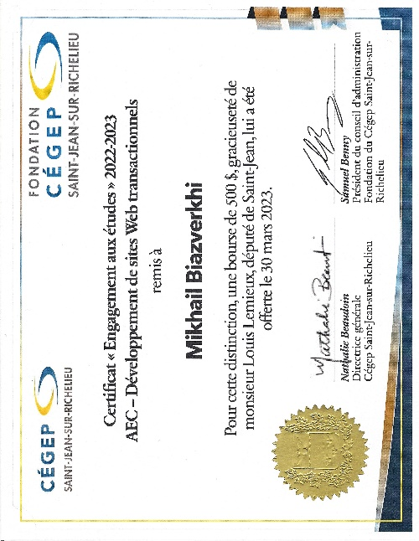

-----------------------------------------------------------------------------------------------------------------------------

Section : **The contact form (сообщения из контактной формы приходят на электронной почты)**

mikhail.biazverkhi@gmail.com

--------------------------------------------------------- FOOTER ---------------------------------------------------------

**Social networks** (социальные сети)

https://www.linkedin.com/in/mikhail-biazverkhi/

https://www.facebook.com/mikhail.biazverkhi/